1. Introduction
- Give a brief introduction to your project and the list of features, with a special focus on data management (add/change/delete). Stuf.auction sets out to create an interaction between personalities and their fans to raise money for both local and national/international organizations who are improving the human condition. The platform provides a tax-deductible destination for tangible contributions which fans (bidders) can bid for. The winning bid’s net proceeds are split 50/50 between the contributing personality’s national organization and the bidder’s local organizaiton

2. User Interface Design and Prototype
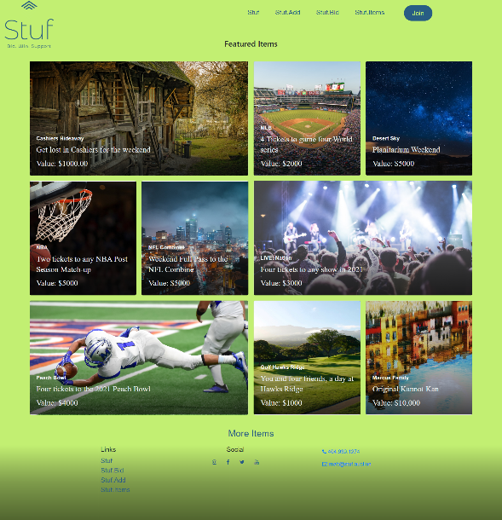
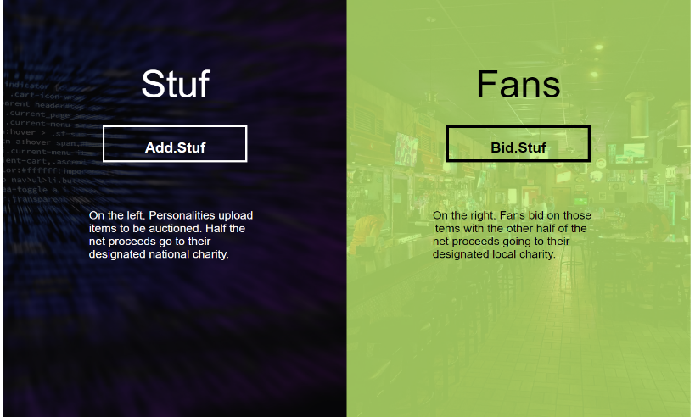
- Give some sample user interface layouts for your application. You can use either wireframe diagrams or prototyping tools to construct the mock representations of your UI design.
- the 50/50 concept is introduced on the landing page
- Briefly explain the rationale behind designing your UI and how it is geared towards supporting the list of features for your application.

3. Navigation Structure
- Give a brief overview of the navigation structure for your application.
- Briefly indicate a typical flow of your application in terms of user experience. You can use any way of representing the flow. You can also construct a prototype using one of the prototyping tools to illustrate this.
- Indicate how your React components are connected to one another (routing).

4. References
- Provide any references relevant to the report.

